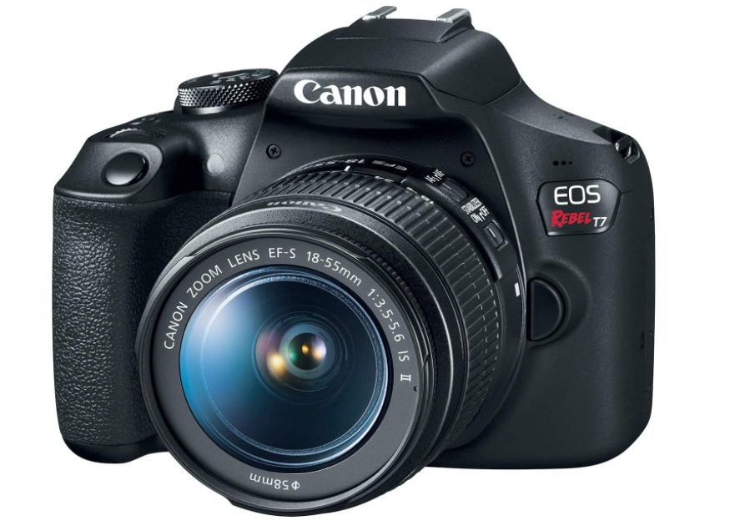

Canon EOS Rebel T7
- 24.1 Megapixel CMOS (APS-C) sensor with is 100–6400 (H: 12800)
- Built-in Wi-Fi and NFC technology
- 9-Point AF system and AI Servo AF
- Optical Viewfinder with approx 95% viewing coverage
- Use the EOS Utility Webcam Beta Software (Mac and Windows) to turn your compatible Canon camera into a high-quality webcam. Compatible Lenses- Canon EF Lenses (including EF-S lenses, excluding EF-M lenses)
Price $1,598.00

